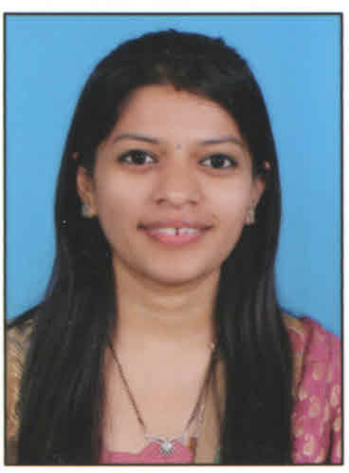
RESUME

Name : Mansata Preeti Jaysukh

Career Objectives:

- Self-motivated, Goal oriented team player, Spirit to run the extra mile.

Work Experience:

Sales Coordinator – December 2014 – Present
Employer Name – Ramya Impex Pvt ltd

Job Profile :-
- Managing all the sales related activity of the company.
- Tracking sales orders to ensure that they are scheduled and sent out on time.
- Effectively communicating with customers in a professional and friendly manner.
- Ordering and ensuring the delivery of goods to customers.
- Preparing quotations for products and services.
- Preparing Proforma invoice.
- Resolving any sales related issues with customers.
- Completing the administrative needs of the Sales Department.
- Making follow-up calls to confirm sakes orders or delivery dates & Payments.
- Responding to sales queries via phone, e-mail and in writing.
- Handling a high volume of customer enquiries whilst providing a high quality of service to each caller.
- Contacting potential customers to arrange appointments.
- Handling Meeting with New Vendors for introducing company profile
- Coordinating with Marketing Executives & Accounts departments.

Educational Qualifications:

 | Examination | University | Year | Class
1 | MA-Economics | Mumbai | April-2008 | 2nd class
2 | BA | Mumbai | March-2006 | 1st Class
3 | H.S.C. | Mumbai | Feb-2002 | 1st Class
4 | S.S.C | Mumbai | March-2000 | 2nd Class

COMPUTER SKILL:

Operating Systems: DOS, Windows 98, Windows Xp, Ms Office, Ms Excel, DTP.

PAST WORK EXPERIENCE:

- Handling Accounts & Administration in "Shrimad Buddhisagarsuri Diagnostic Centre".

- Job profile :-
-Key Deliverables
    - Maintain cash transaction of lab charges.

    - Attends day to day inquiries and make arrangement of the diagnosis for patient.

    - Make follow-ups for receivables

    - Negotiate with Vendor for material purchase and prepare Purchase Order.

    - Assist to Prepare Contract documents for advertising.

    - Maintain Day to day attendance of employee and leave management.

    - Manage day to day Documentation.

    - Reconciliation done on weekly basis.

    - Manage timely payment of utility bills.

    - Keeping records of all legal certificates.

    - Making timely payments to the vendor.

- 3 years vacation job in “THE MALAD SAHKARI BANK LTD” (Main Branch)
- As a Clerk in Saving Department.

Job profile:
- Cheques Clearance.
- Making Payments.
- Transfer of payment, ECS entry.
- Opening & Closing of Saving Bank A/C
- Cheque returns charges.
- Pass Book entry.
- As a Work Appreciation got Promotion to work in A Central Office of “MALAD SAHAKARI BANK” Under Branch Officer.
Job Profile:
- Fund Transfer
- Bank to Bank Relation
- Maintaining Bank’s Passbook

- 2 years’ Experience in online Marketing of an Australian Co. “Synergy”.

Highlights of Skills:

- Excellent organizational, communication and interpersonal skills.
- Leader in the BAPS Youth Activity of Miraroad Since last 10 yrs.
- We had organised & conducted several successful Events to manage & run these youth activity.

Extra-Curricular Activities:
- Participation in Singing, Dance, Drama, Public Speaking, Essay Writing, (Drama) Script Writing, as a Volunteer of Youth Wings BAPS Swamiarayan Sanstha.
- Performed More than 30 Professional Dance Programme till 2012.
- Wrote Article” Womens OF 18th Century” in “Premvati” world-wide Spiritual Magazine of BAPS Swainarayan Sanstha.

Achievements and Honours:

- 2nd prize in Elocution compitition in BAPS (Leaders of youth Activity) Championship in 2013.
- 3 Gold Medals in BAPS Swminarayan Advance level Philosophical & Spiritual test”Pragnya” .
- 1st prize in Drama Script Writing in BAPS Youth Compitition.
- DANCE PARTICIPATION
- On the occassion of BAPS 100 Years Celebration which was live telecast on Aastha Channel in 2007.
- The inaugural Ceremonial Dance Programme at “Delhi - AKSHARDHAM” (Biggest temple in the world!!) in the Presence of “Betiji” & C.M of Delhi Smt. Shila Dixit,in 2005
- Performance in “Amrut Mahotsav” (Spiritual – Cultural Festival)
2 Months Dance Programme Mumbai in 1995.

Personal Information:

Address : 401/ D-20, Sector – 7, Shanti Nagar, Mira Road (East), Thane - 401107.

Mobile no : 8767554253/9987221457

Email Id : preetu.baps@gmail.com

Nationality : Indian

Gender : Female

Date of Birth : 4th April’ 1985 Age: 30 yrs

Marital Status : Married.

Linguistic Proficiency: English, Hindi, Gujarati and Marathi.

( Mrs. Preeti. J Manasata)

